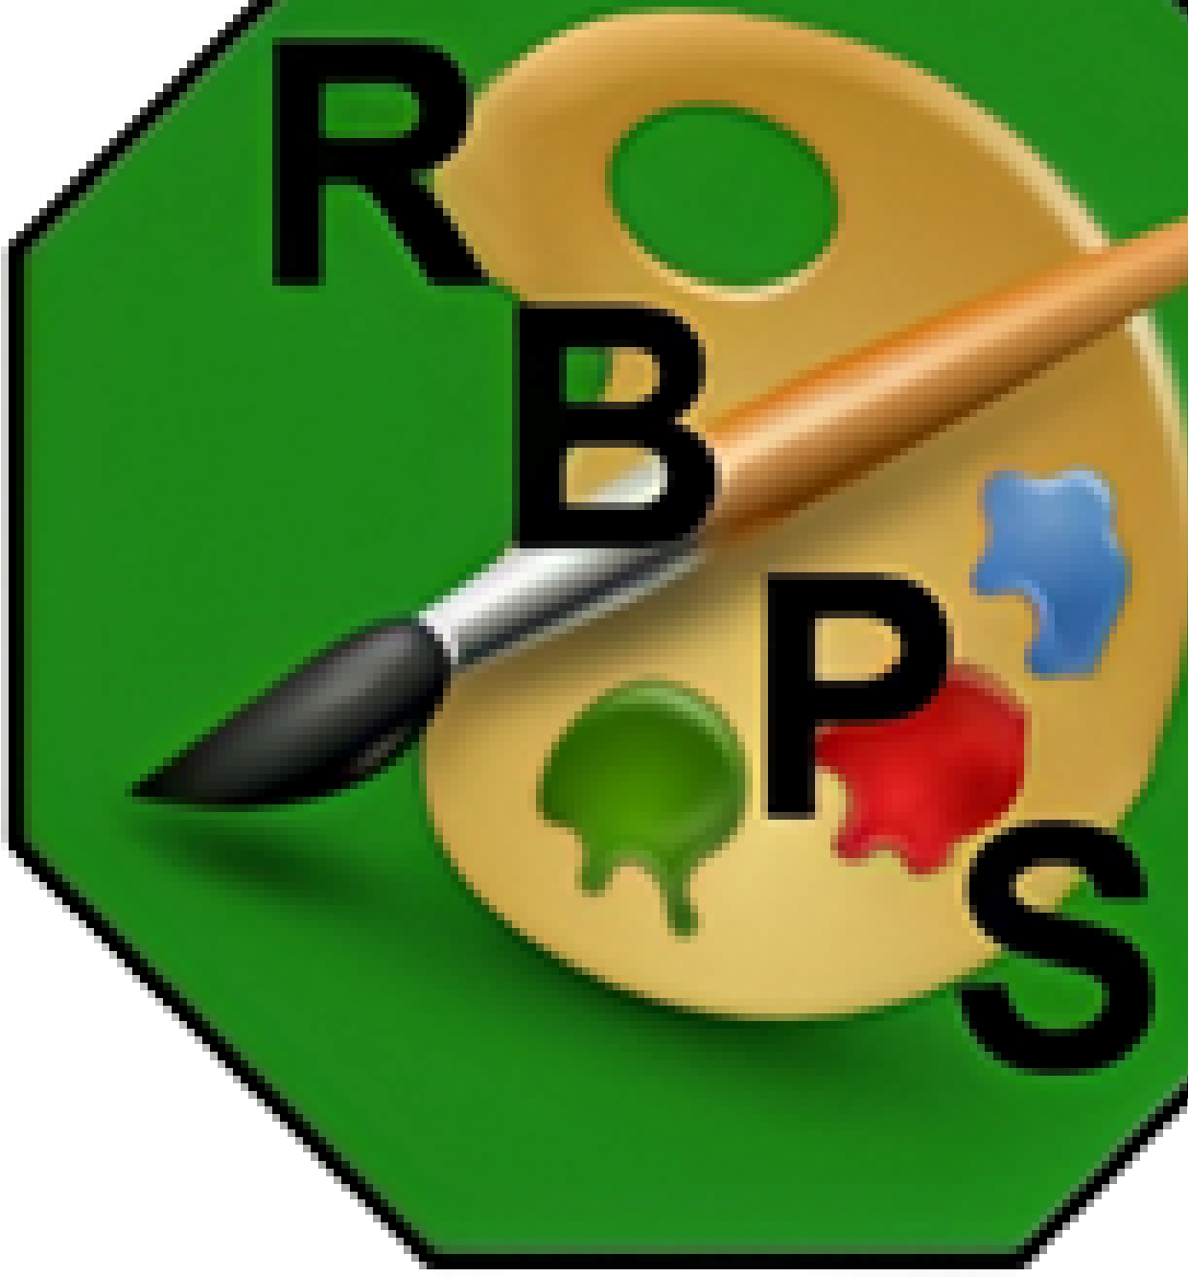


Richard Bonington
Primary School.

Uniform Policy.

Date adopted | Sept 2026
To be reviewed | Sept 2029

RICHARD BONINGTON PRIMARY SCHOOL ⏐ Calverton Road ⏐ Arnold ⏐ Nottingham ⏐ NG5 8FQ ⏐ 0115 956 0995 ⏐ admin@rbps.org.uk
Our rationale.

Our school community values both high standards and the wellbeing of every child. In developing our updated uniform policy, we listened carefully to feedback from pupils, parents, and staff. While many families welcomed the move toward a more active, practical uniform, others expressed a preference for more traditional options.

To reflect the diverse needs and views within our community, this policy offers choice and flexibility. The uniform range includes items that support active movement, cater for sensory and functional needs, and remain smart and school-appropriate. By providing options, we aim to ensure every child feels comfortable, confident, and ready to learn.

At the same time, the policy maintains core elements of consistency. These shared aspects help to create a strong sense of belonging, promote equality, and uphold our school identity.

Overall, this uniform policy seeks to balance practicality, inclusivity, and pride in our school, ensuring that all children can engage fully in school life.

If your child opts for a more traditional uniform, they will need to wear items from the PE section on the days they are scheduled for PE.

You are welcome to buy unbranded uniform from local shops. The company that offers our branded uniform is Just Schoolwear | Order Online

School Uniform
Jumper | 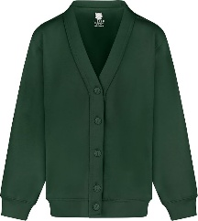  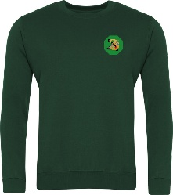  RBPS branded green cardigan or jumper. |  |  | 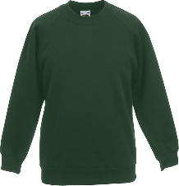  Supermarket own brand green cardigan or jumper. |  |  | 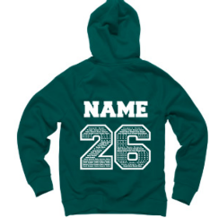  Year 6 only- Leavers’ hoodie
Top | 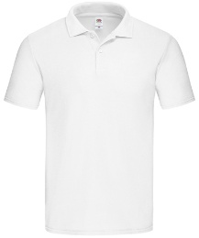  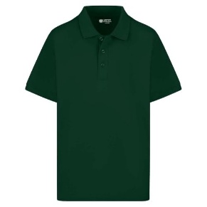  Supermarket own polo shirt- white or bottle green. |  |  |  | Branded polo shirt- white or bottle green.
Bottoms | 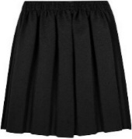  Black skirt | 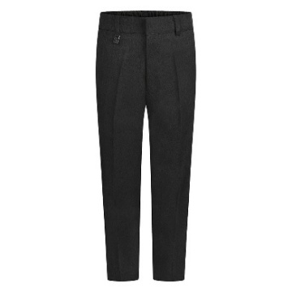  Black trousers | 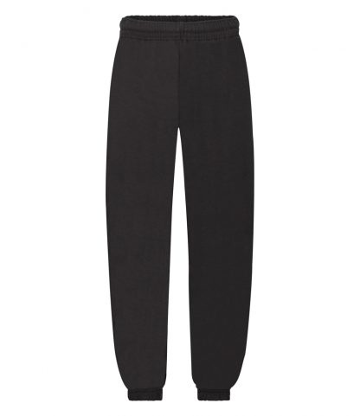  Plain black jogging bottoms (no logo) |  | 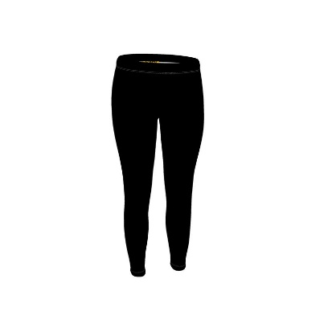  Plain black leggings (no logo) | 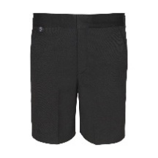  Black tailored knee length shorts |  | 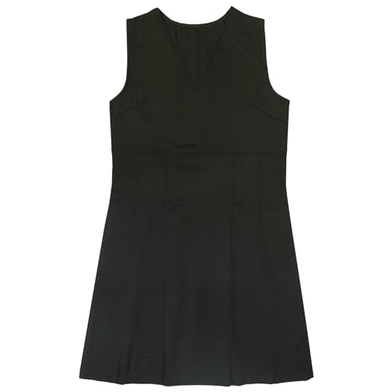  Black pinafore dress
Shoes | 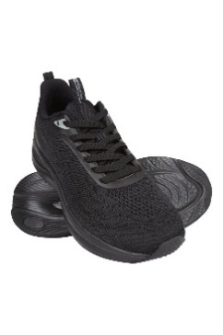  Plain black trainers |  | 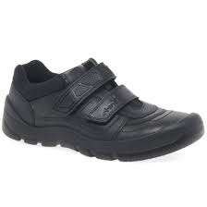  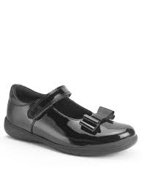  Sensible, flat black shoes |  |  | 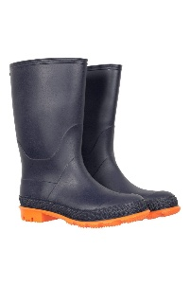  Wellington boots.
Tights- black or grey. Socks- black or grey
Summer uniform- optional
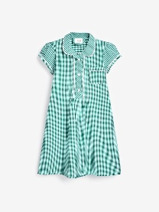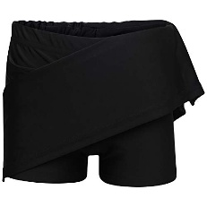
Green checked dress Black skort
No nail varnish or jewellery (unless agreed for religious reasons)

PE kit.
Jumper | 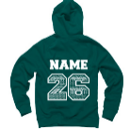  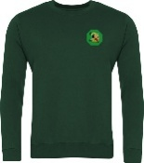  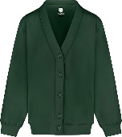  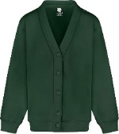  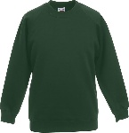  RBPS branded green cardigan or jumper/Supermarket own brand green cardigan or jumper/Year 6 only- Leavers’ hoodie |  |  | 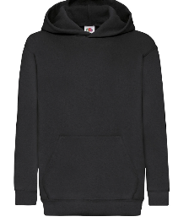  Plain black hoodie- zip up or over the head. |  |  | 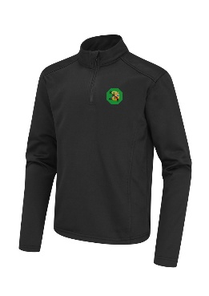  Branded black sports top
Top | Polo shirt- white or bottle green/branded or unbranded |  | 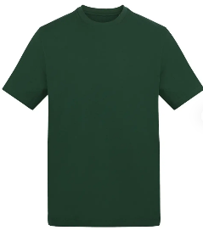  Green or white t-shirt |  |  | 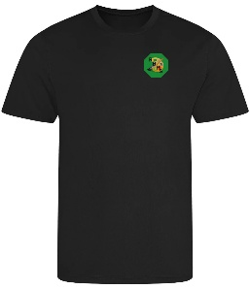  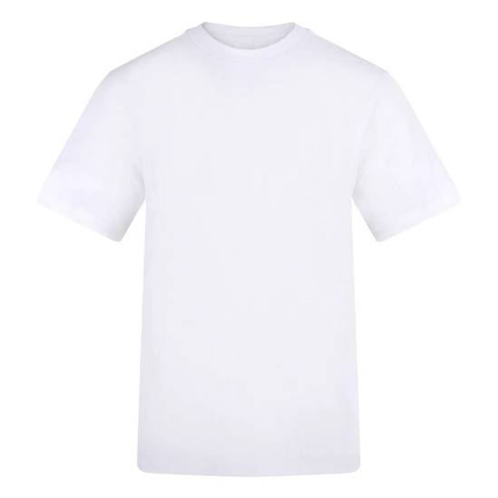  Branded black PE t-shirt.
Bottoms | 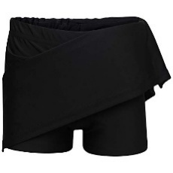  Plain black skort | 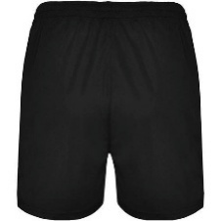  Plain black sports shorts |  |  | Plain black jogging bottoms (no logo) |  |  | Plain black leggings (no logo)
Shoes | Plain black trainers

