SENSORY PLAY

How about trying a range of activities to stimulate all the five senses – touch, smell, taste, sight and hearing. These types of activities can be helpful in improving coordination, improving fine/gross motor skills, calming children down when they are agitated and are fun! Here are a few ideas:

**1. Scented playdough**

Make up a large batch of [playdough](https://www.wesco-eshop.co.uk/54604020-pack-of-play-doh-modelling-clay-2-68-kg.html) and divide it into separate bowls. Mix different ingredients into each bowl, to create easily identifiable smells, for example cinnamon, almond essence, lemon juice, vanilla essence, ginger and so on (you could also add food colouring). While the children play with the dough they can enjoy the different smells and try to guess what they are. Here is a link to a basic playdough recipe – don’t forget to add different scents.

<https://youtu.be/oAIAm6BF0fs>

**2. Car wash**

Set up a car washing station outside in the garden – with bowls of water, soap, [sponges](https://www.wesco-eshop.co.uk/22478014-round-sponges.html)/brushes/cloths/towels and a selection of [plastic vehicles](https://www.wesco-eshop.co.uk/54357020-small-metal-cars.html). The children will love playing with the soapy water, scrubbing the cars clean and drying them off again.

**3. Mud kitchen**

If you have the space, it’s really worth setting up a mud kitchen as they are very popular, particularly with children who are drawn to sensory activities. You can buy readymade mud [kitchens](https://www.wesco-eshop.co.uk/of53447-gourmet-kitchen-fridge-trio-wesco.html), or make your own by repurposing cast-offs or building from scratch. Make sure there are also plenty of [utensils](https://www.wesco-eshop.co.uk/54336171-plastic-doll-s-tea-set-kitchen-utensils-kit-wesco.html) and tools available to play with.

**4. Homemade musical instruments**

There are lots of different [musical](https://www.firstdiscoverers.co.uk/5-best-musical-toys-early-years/) instruments that you can make with children, and creating them can be just as much fun as playing with them. Ideas include shakers (e.g. fill plastic bottles with rice or dried beans), rattles (e.g. thread buttons or beads onto some string), drums (e.g. use [wooden spoons](https://www.wesco-eshop.co.uk/21737016-maxi-pack-of-wooden-spoons.html) to beat on plastic tubs) and chimes (hang up some bottle tops or shells).

**5. Footprint painting**

For this activity you’ll need a large roll of paper and some trays of paint, as well as paper towels and water on hand for cleaning the paint off the children’s feet. You could try to create a particular scene (e.g. [paint](https://www.wesco-eshop.co.uk/52726171-acrylic-paint-maxi-pack.html) some circles and then get the children to make footprint petals around them or create different minibeasts), or just let them go freeform.

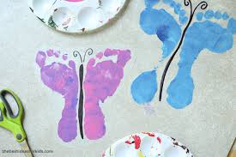

**6. Tasting game**

In this game the children taste different kinds of food while blindfolded, and then guess what it is. Your choice of food will obviously depend on the likes/dislikes of the children but bear in mind that this game can be a good way of introducing new tastes and textures. Your list might include things like yoghurt, cereal, jelly, rice cakes, bananas, bread, tomato sauce, satsumas and guacamole.

**7. Cornflour slime**

This homemade slime is great to play with as it has unusual properties – it is a cross between a liquid and a solid. In a large shallow container, mix cornflour and water until you have a slime consistency. If you punch the slime it instantly turns solid, but when you scoop some up and hold it, it will turn back into a liquid.

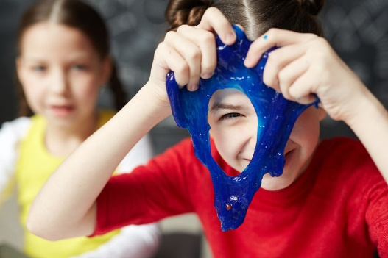

**8. Frozen toys**

You’ll need to prepare this activity a day or two ahead. Find a large plastic box that will fit in your freezer, quarter fill it with water, put some toys in and freeze. Add three more layers, and then turn out your ice block. The children then have to get the toys out of the ice, using a selection of tools (e.g. spray bottles with warm water in, toy hammers etc).

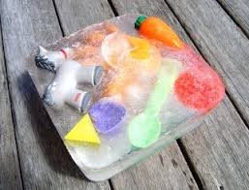

**9. Sand table**

Sometimes the simplest activities are the best. Most children love playing with sand, so invest in (or build) a [sand table](https://www.wesco-eshop.co.uk/gp32975-small-sand-and-water-activities-table-wesco.html), along with a good selection of [resources](https://www.wesco-eshop.co.uk/48248171-sand-games-wesco.html) for them to play with – buckets, rakes, moulds, sieves and so on.

**10. Bubble snakes**

For this activity you’ll need plastic bottles, socks and bubble mixture. Cut the bottoms off the bottles, and put the socks over the ends, pulling them all the way over the bottle and then folding them back so you have a tight fit. Dip the sock-covered end into the bubble mixture and blow through the top end to make lovely long bubble snakes.